Student Name: ERIC VARA

**Project: N-Sided Regular Polygon**

Problem Description:

Write a program that displays a regular polygon and uses two buttons named +1 and -1 to increase or decrease the size of the polygon, as shown in the following figure.

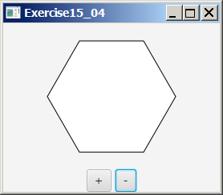 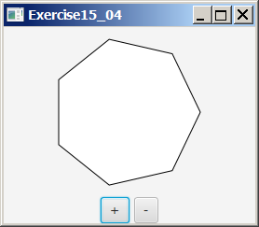 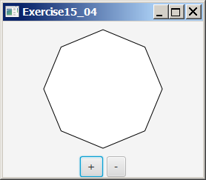

Your Task:

1. Create the RegularPolygonPane class for displaying an n-sided regular polygon. n is a data field in RegularPolygonPane.
2. Write the code to handle the action events from the buttons to change the number of the sides in a RegularPolygonPane object and redisplay it.

Submit the following items:

1. Compile and Submit (you must submit the program regardless whether it complete or incomplete, correct or incorrect)

/************************************************************************************

*

* Write a program that displays a regular polygon and uses two buttons named +1

* and -1 to increase or decrease the size of the polygon.

*

* 1. Create the RegularPolygonPane class for displaying an n-sided regular

* polygon. n is a data field in RegularPolygonPane.

* 2. Write the code to handle the action events from the buttons to change the

* number of the sides in a RegularPolygonPane object and redisplay it.

*

************************************************************************************/

package application;

import java.awt.*;

import java.awt.event.*;

import javax.swing.*;

public class RegularPolygonPanel extends JFrame implements ActionListener {

JButton btnMinus = new JButton("-1"); // Created button object to decrease shape size

JButton btnPlus = new JButton("+1"); // Created button object to increase shape size

JPanel panel = new JPanel(); // Created Panel object named panel

PolyPanel poly = new PolyPanel(); // Created PolyPanel object named poly

public RegularPolygonPanel() { // Default class constructor named

panel.add(btnPlus); // Added plus buttons to panel

panel.add(btnMinus); // Added minus buttons to panel

add(poly, BorderLayout.CENTER); // Positioned pane in center

add(panel, BorderLayout.SOUTH); // Positioned panel at bottom

btnPlus.addActionListener((ActionListener) this); // Added actions to plus button

btnMinus.addActionListener(this); // Added actions to minus button

} // Close Method

public void actionPerformed(ActionEvent e) { // *****Handler for buttons*****

if (e.getSource() == btnMinus) { // Checked source for btnMinus

poly.decreaseSize(); // Decrease Polygon size

} else if (e.getSource() == btnPlus) { // Checked source for btnPlus

poly.increaseSize(); // Increased Polygon size

} // ********Close Method*********

}

public static void main(String[] args) { // ***************Main Method***************

JFrame javaFrame = new RegularPolygonPanel(); // Created a JFrame object named javaFrame

javaFrame.setTitle("Program 4"); // Set panel title equal to Program 4

javaFrame.setLocationRelativeTo(null); // Set javaFram location

javaFrame.setSize(300, 350); // Set javaFrame size

javaFrame.setVisible(true); // Allowed javaFrame visibility

} // ***************Close Method**************

class PolyPanel extends JPanel { // Created inner panel named PolyPanel

private int size1 = 0; // Declared new size variable named size1

private int size2 = 6; // Declared new size variable named size2

public void decreaseSize() { // method to reduce size2

size2--; // reduces size of Polygon

repaint(); // refreshes shape

} // ******close method******

public void increaseSize() { // method to increase size2

size2++; // Increases size of Polygon

repaint(); // refreshes shape

} // ******close method*******

protected void paintComponent(Graphics g) { // Overrides paint

size1 = (int) (Math.min(getWidth(), getHeight()) * 0.4);

int a = getWidth() / 2; // Calculate width

int b = getHeight() / 2; // Calculates height

super.paintComponent(g); // Called super class to refresh shape Polygon object named Pol

Polygon pol = new Polygon(); // Created new

pol.addPoint(a + size1, b); // called addPoint method

for (int i = 1; i < size2; i++) {

pol.addPoint((int) (a + size1 * Math.cos(i * 2 * Math.PI / size2)),

(int) (b - size1 * Math.sin(i * 2 * Math.PI / size2)));

}

g.drawPolygon(pol);

}

}

}

2. Fill in self-evaluation:

1. Can your program create the UI? Yes
2. Can your program display one polygon correctly? Yes
3. Can your program display n-side polygon correctly? Yes
4. Can your program handle action event from the buttons? Yes
5. Can your program redisplay the polygon when the user clicks the buttons?
6. Yes
7. Can your program resize the polygon when the user resizes the frame?

Yes